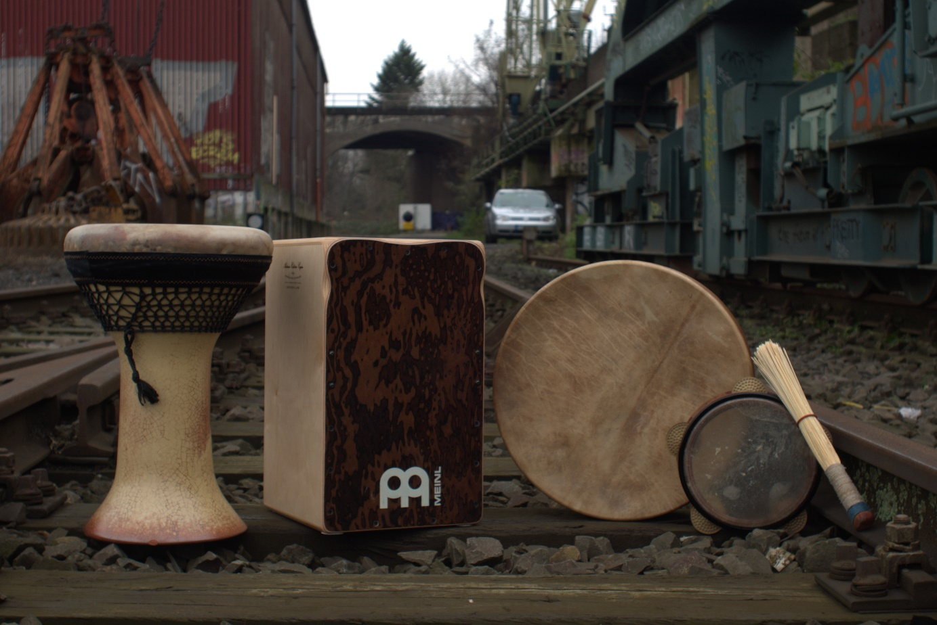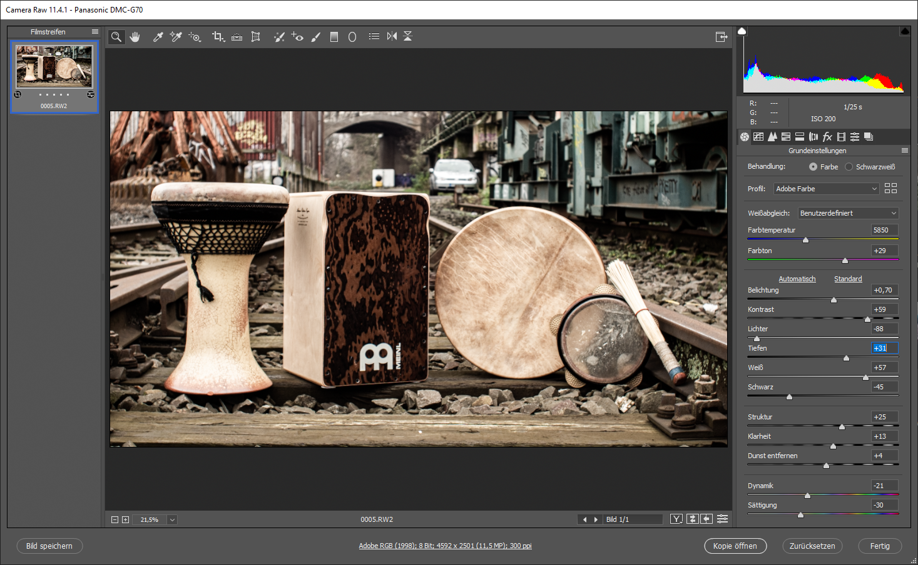

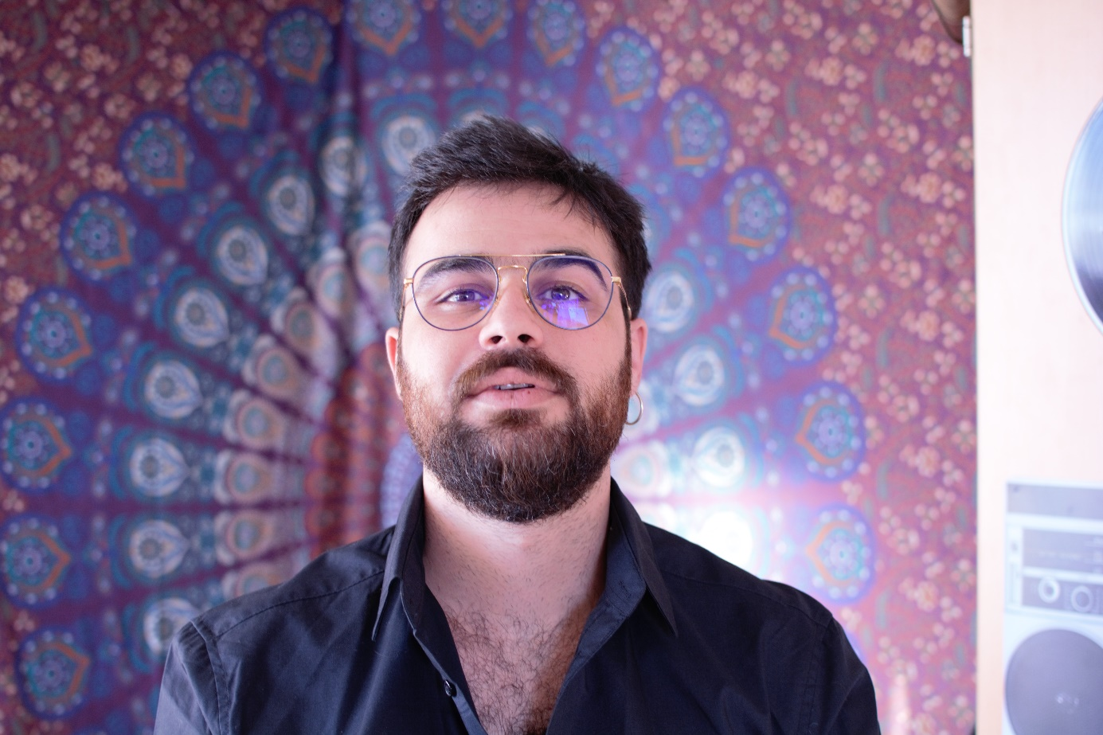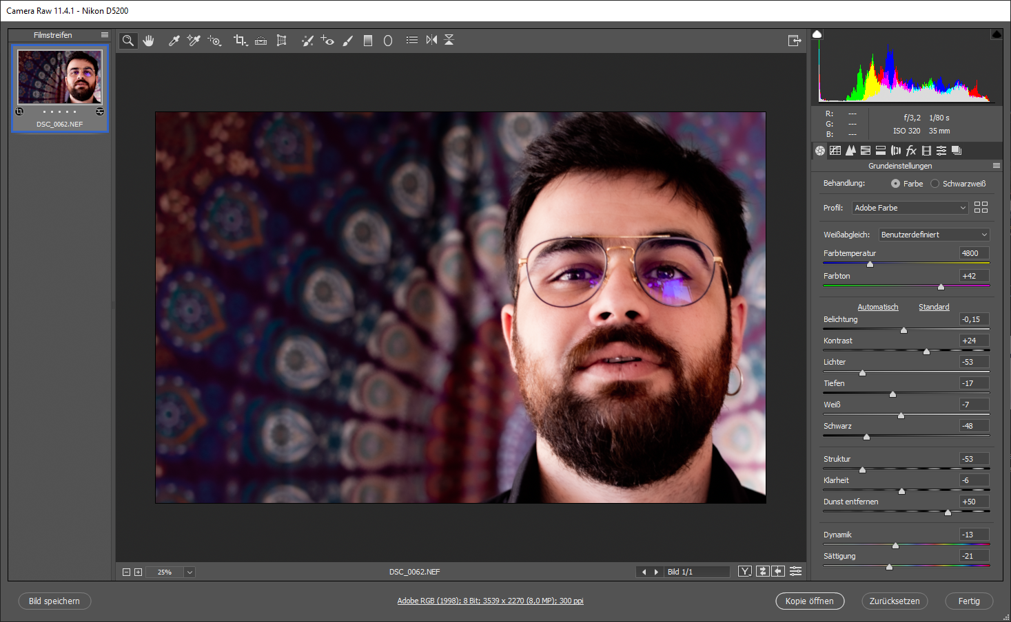

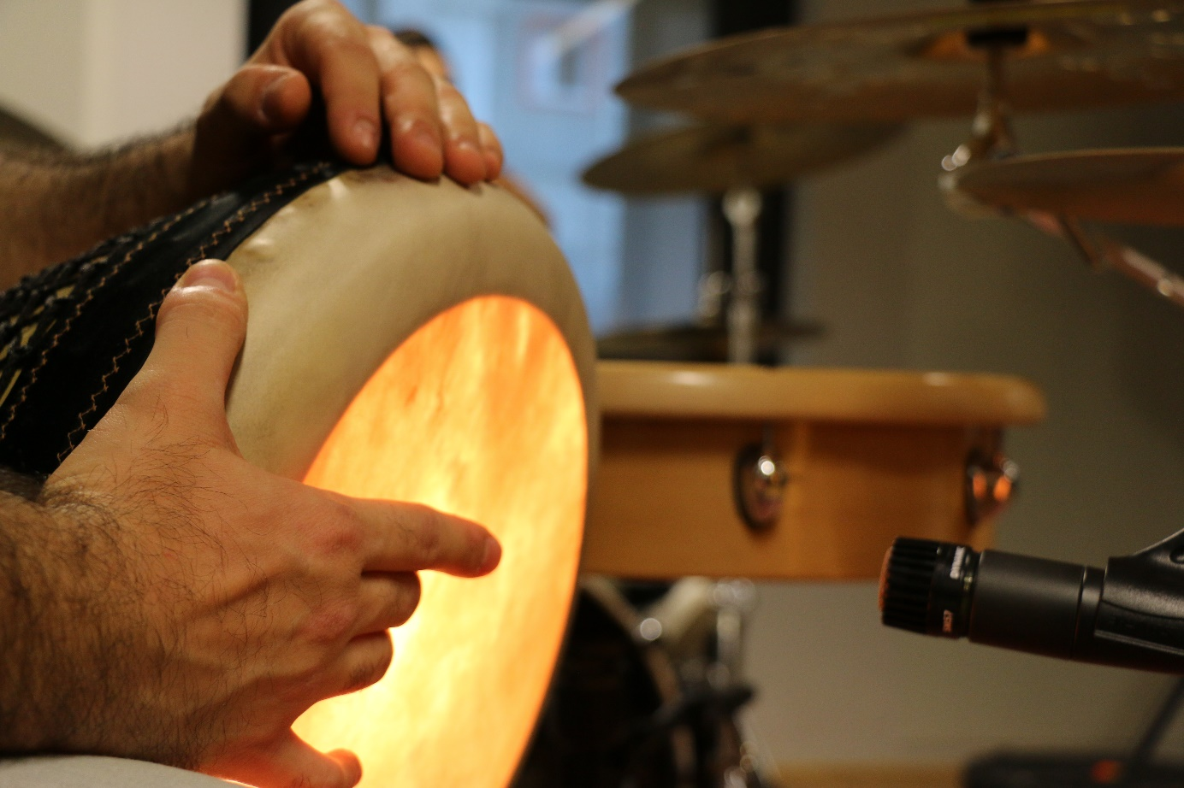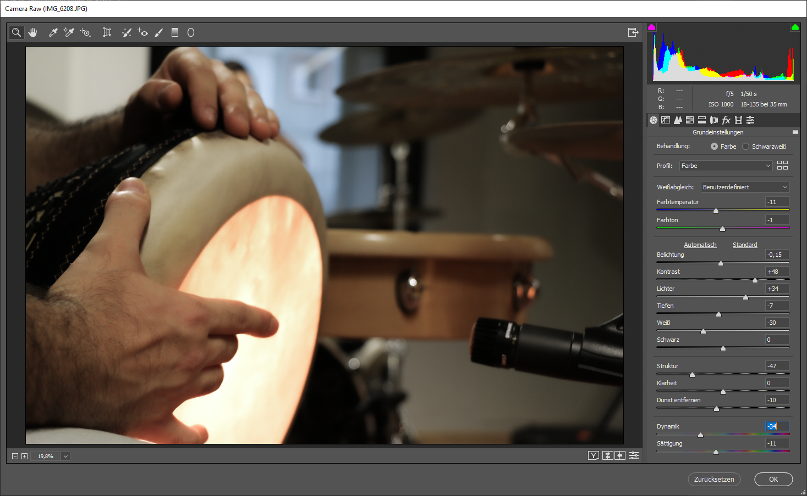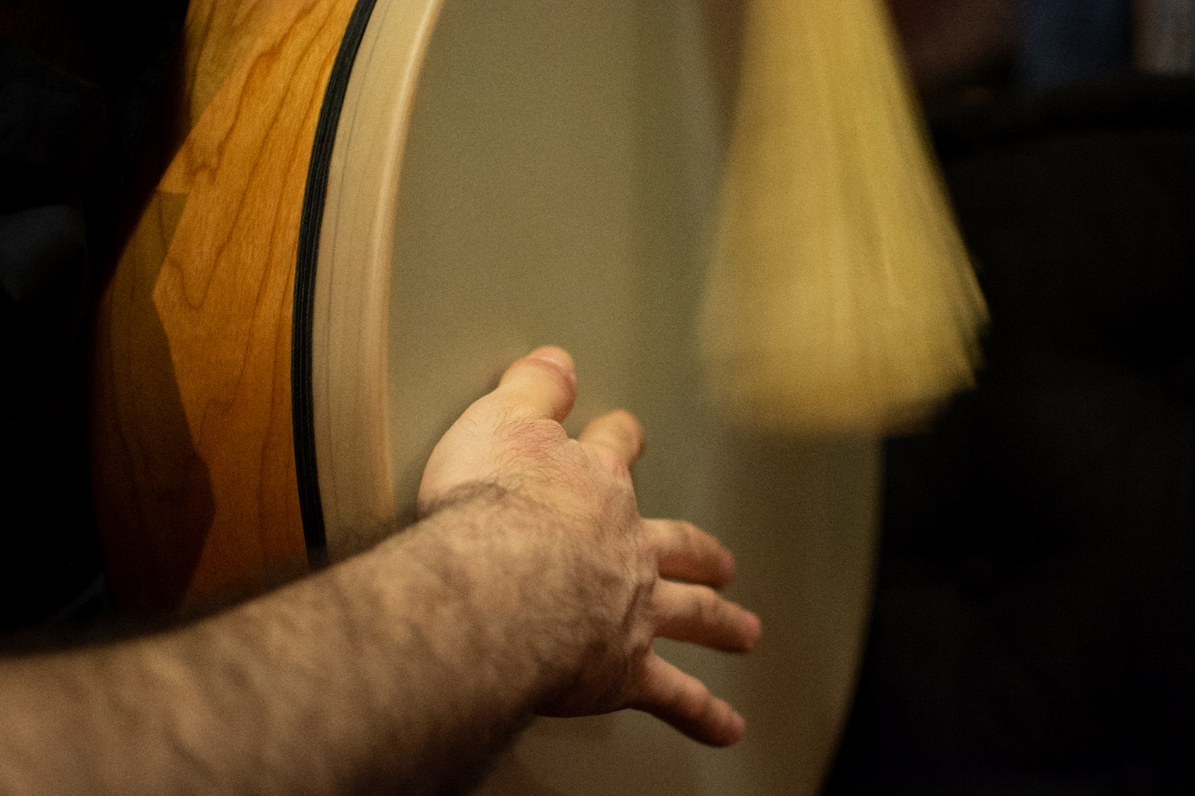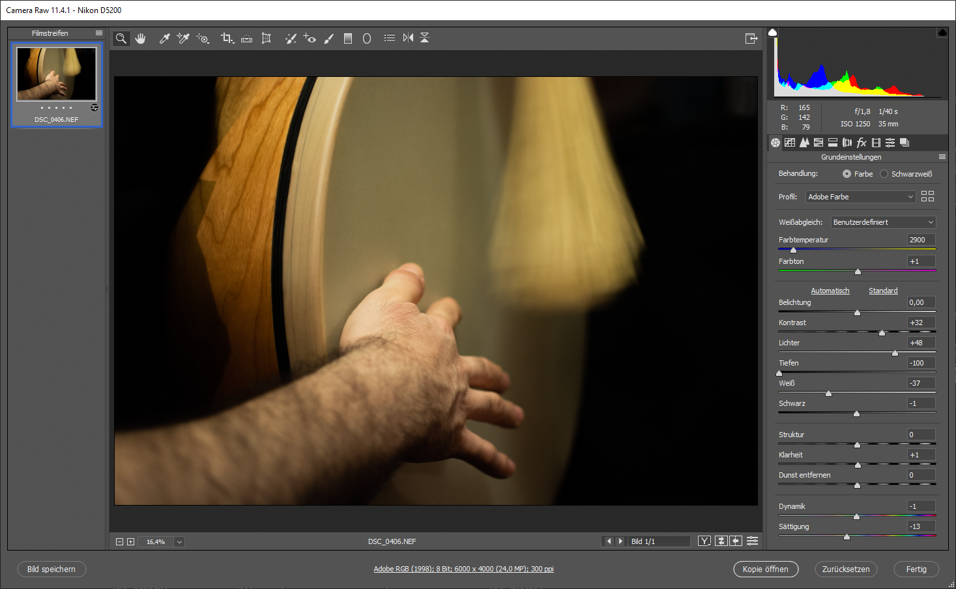

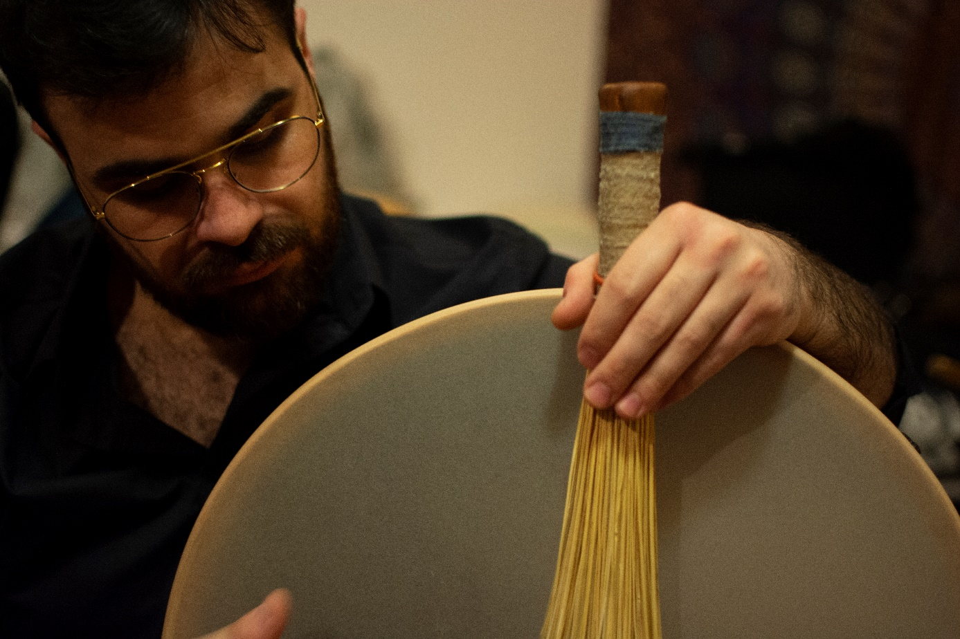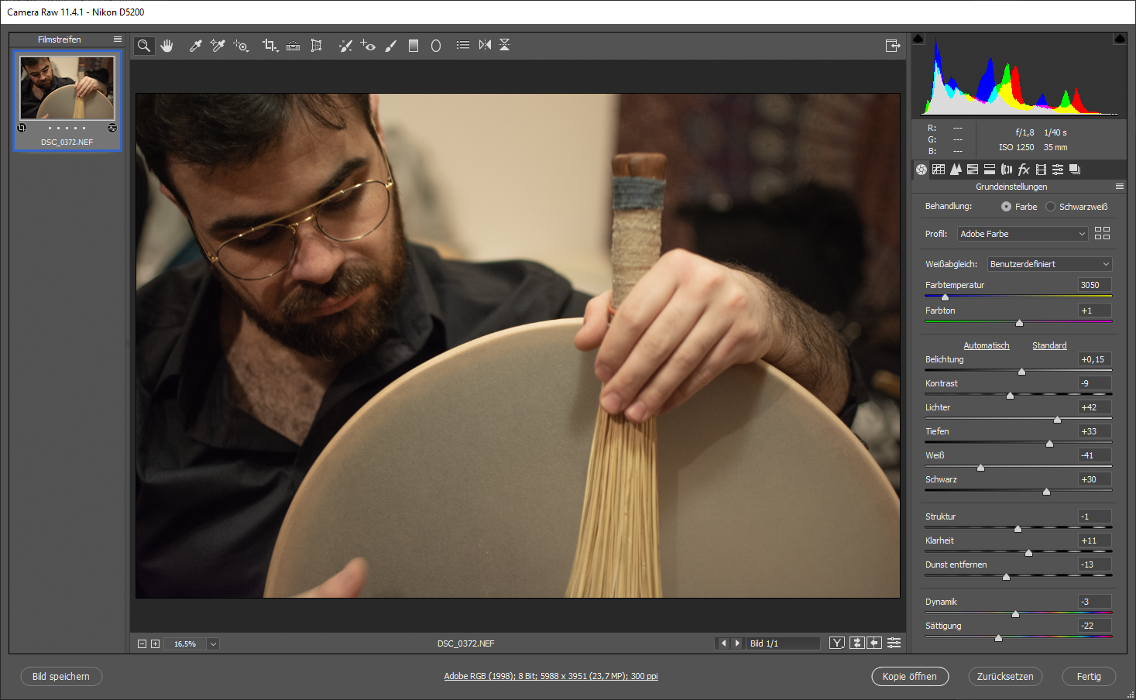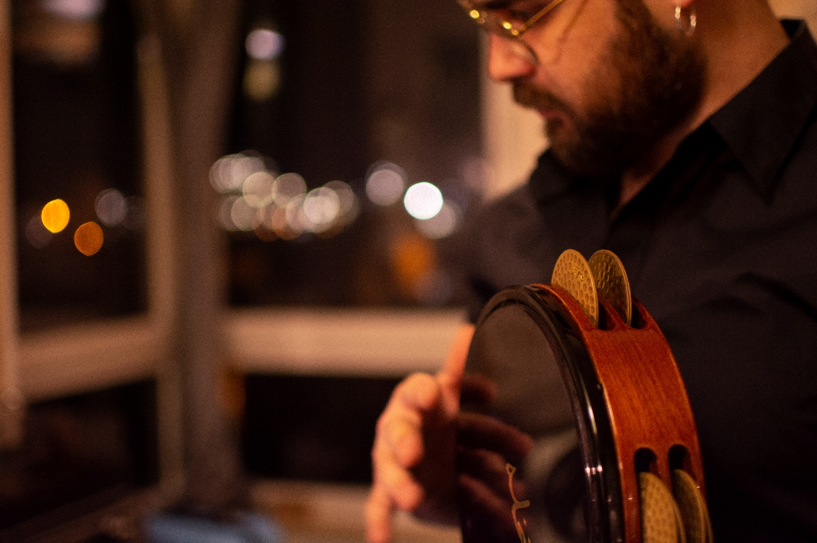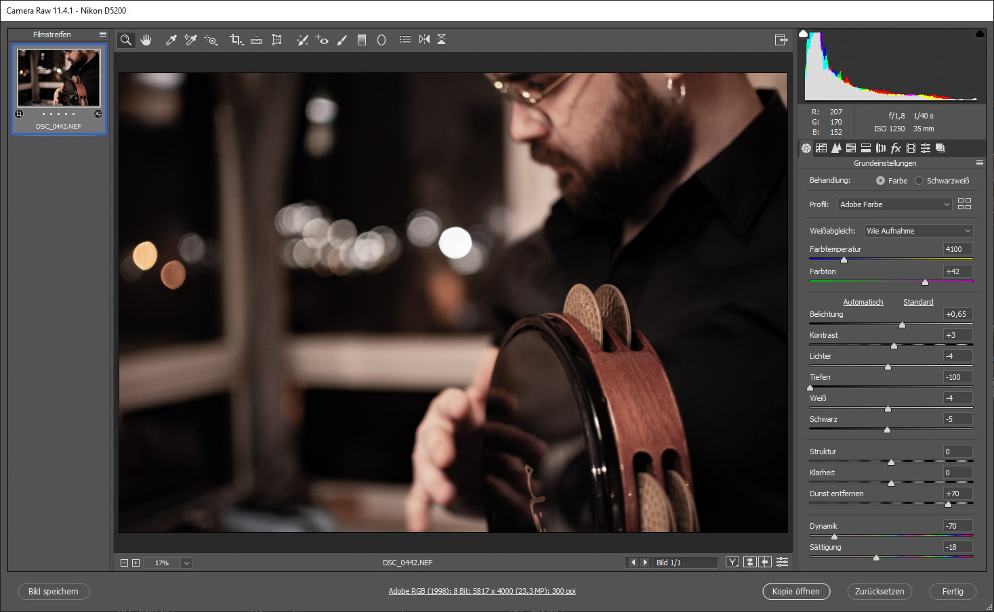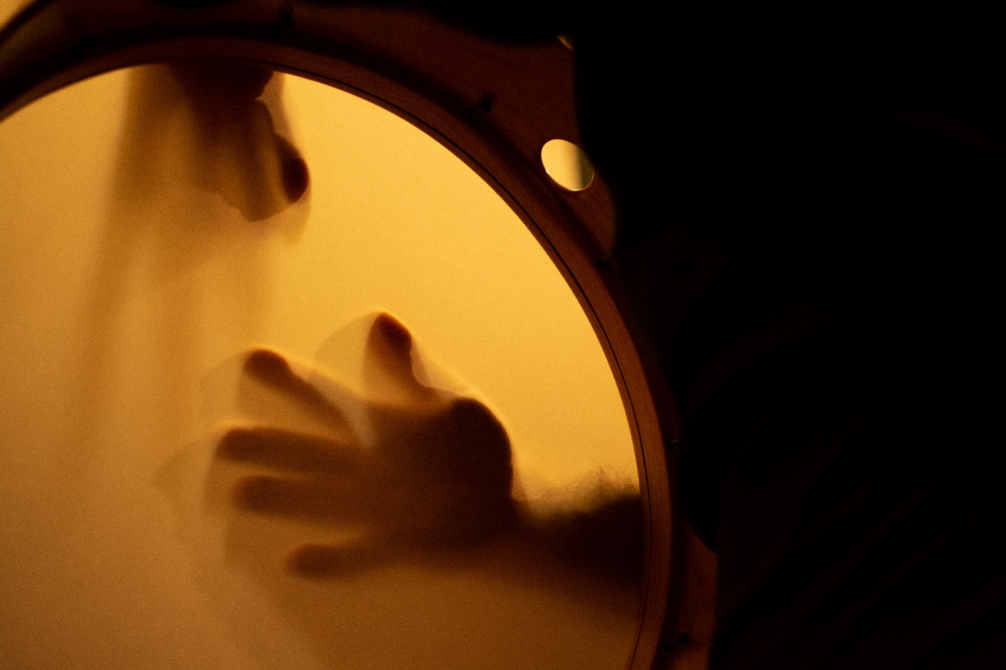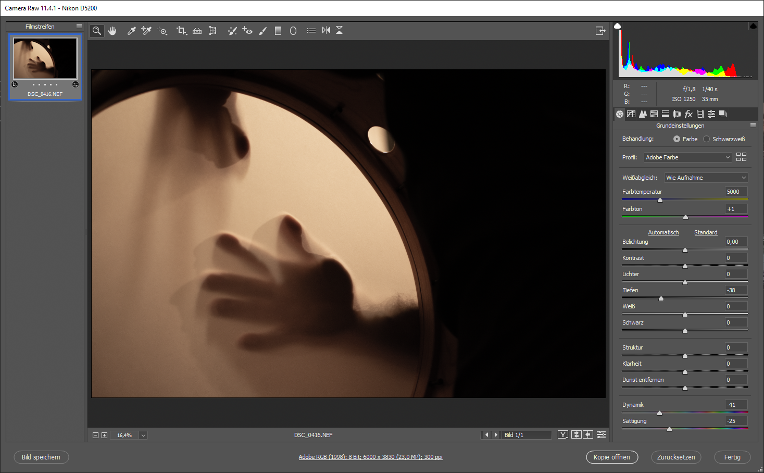

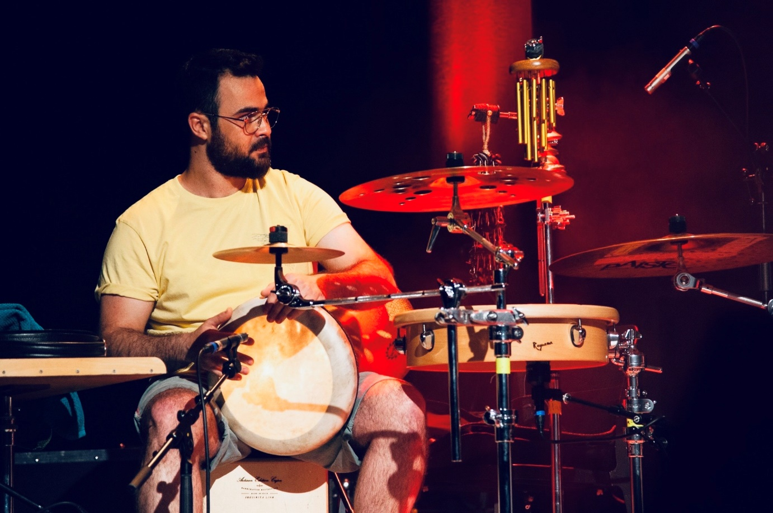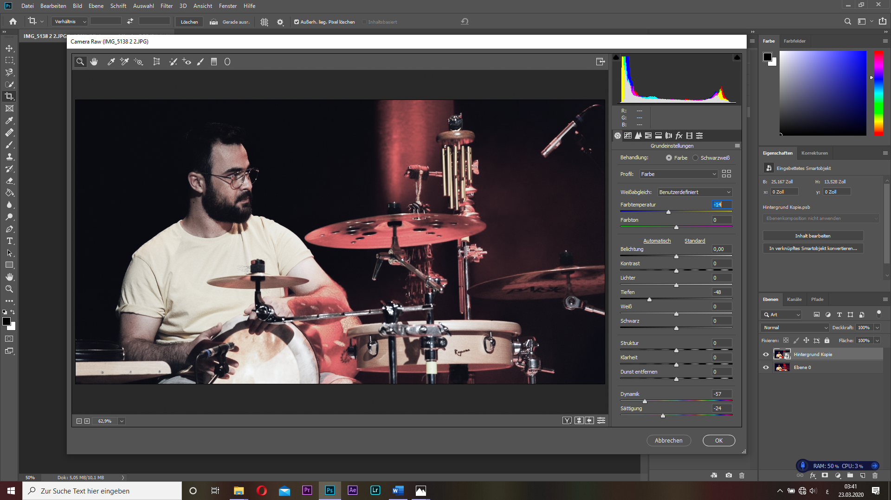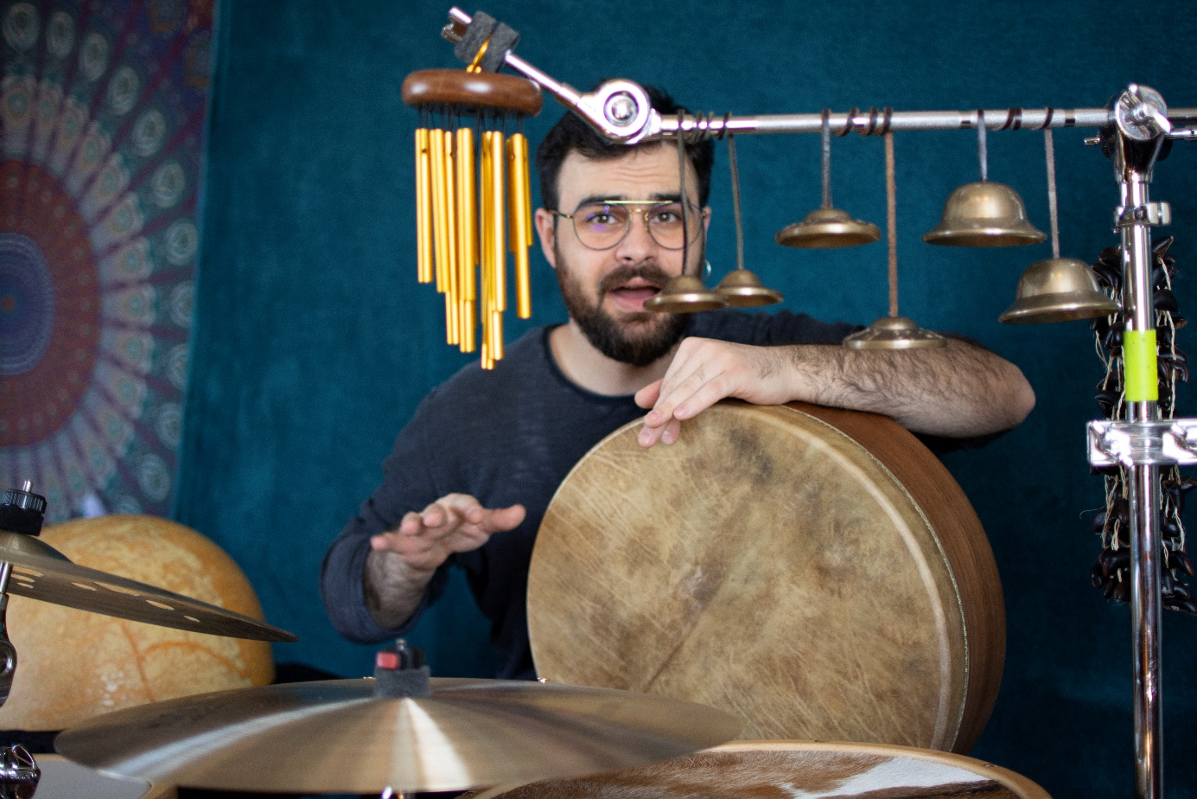

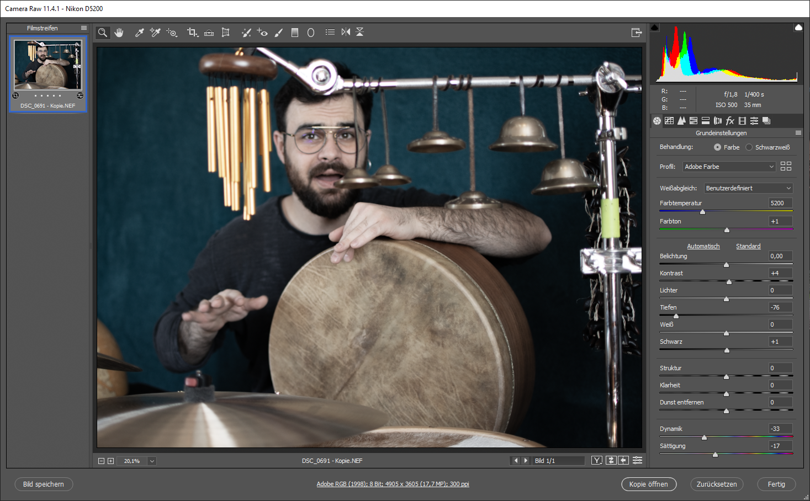

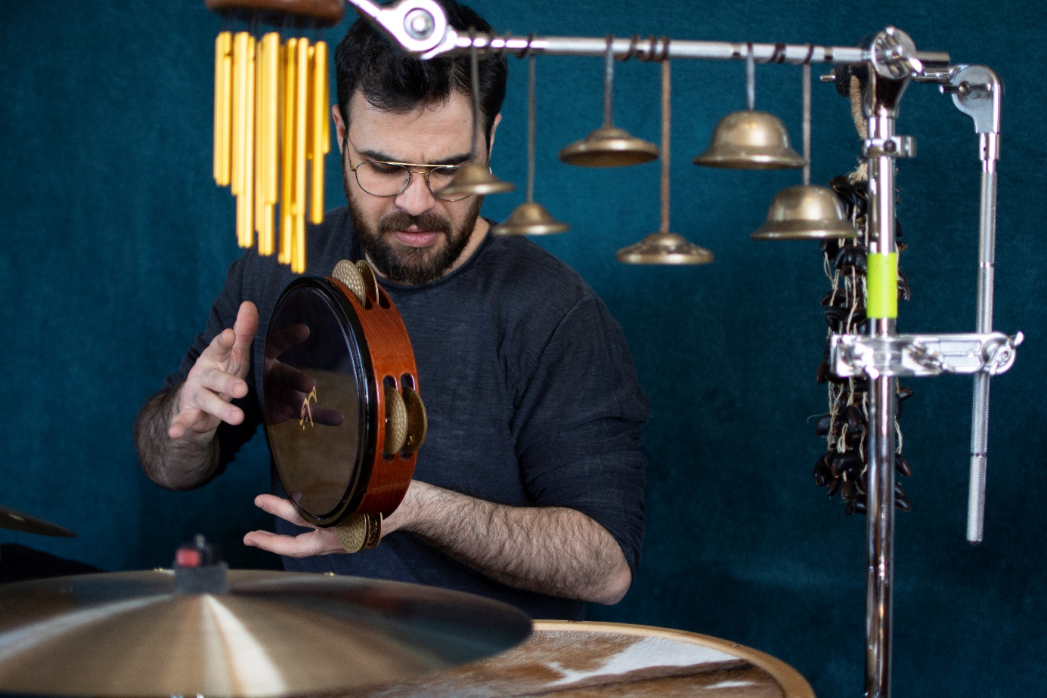

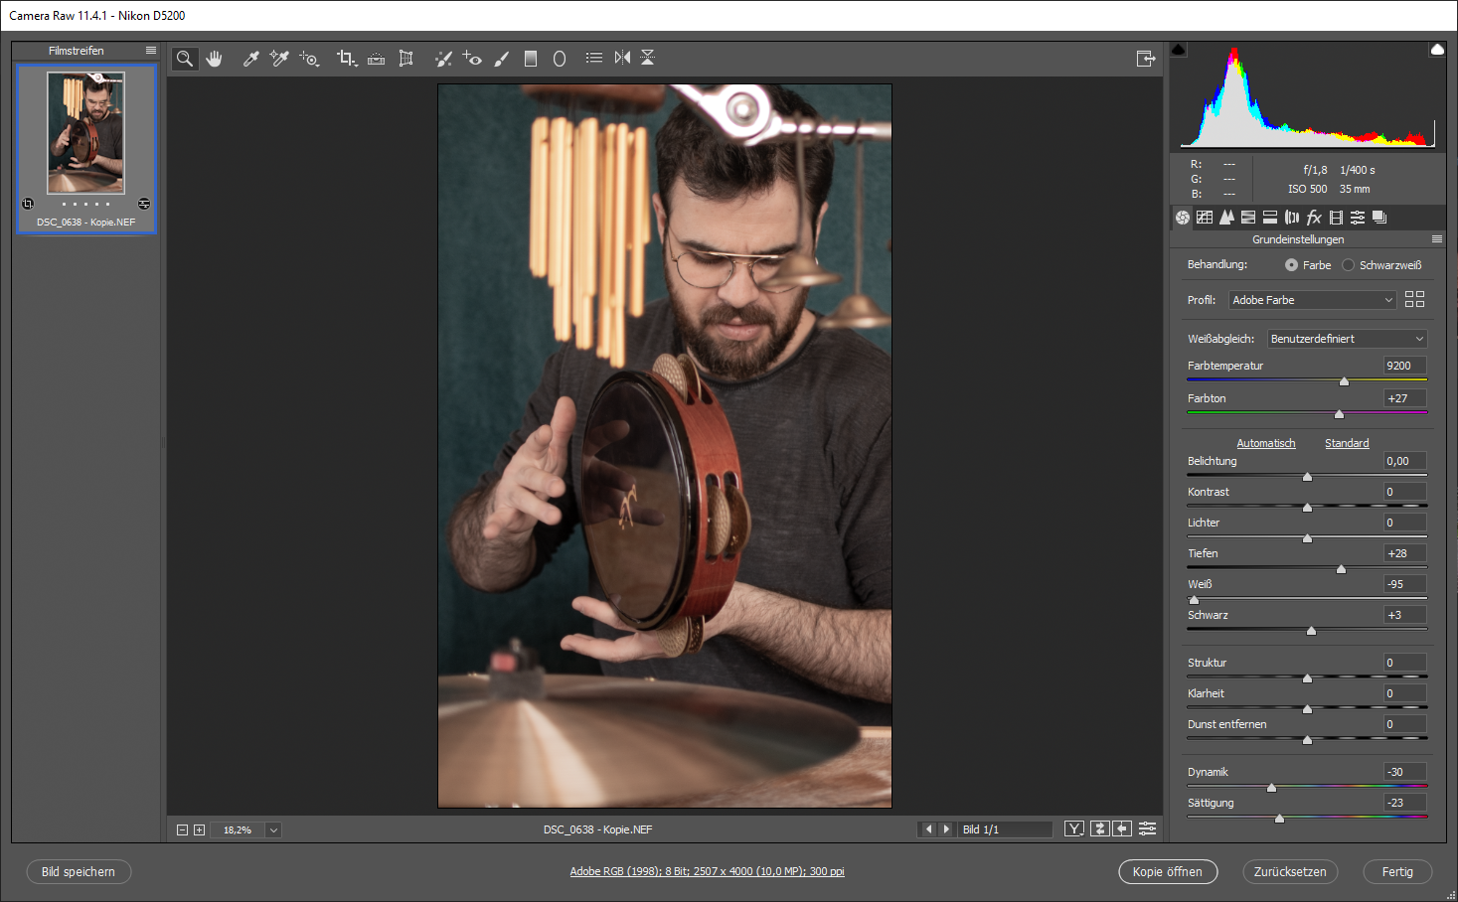

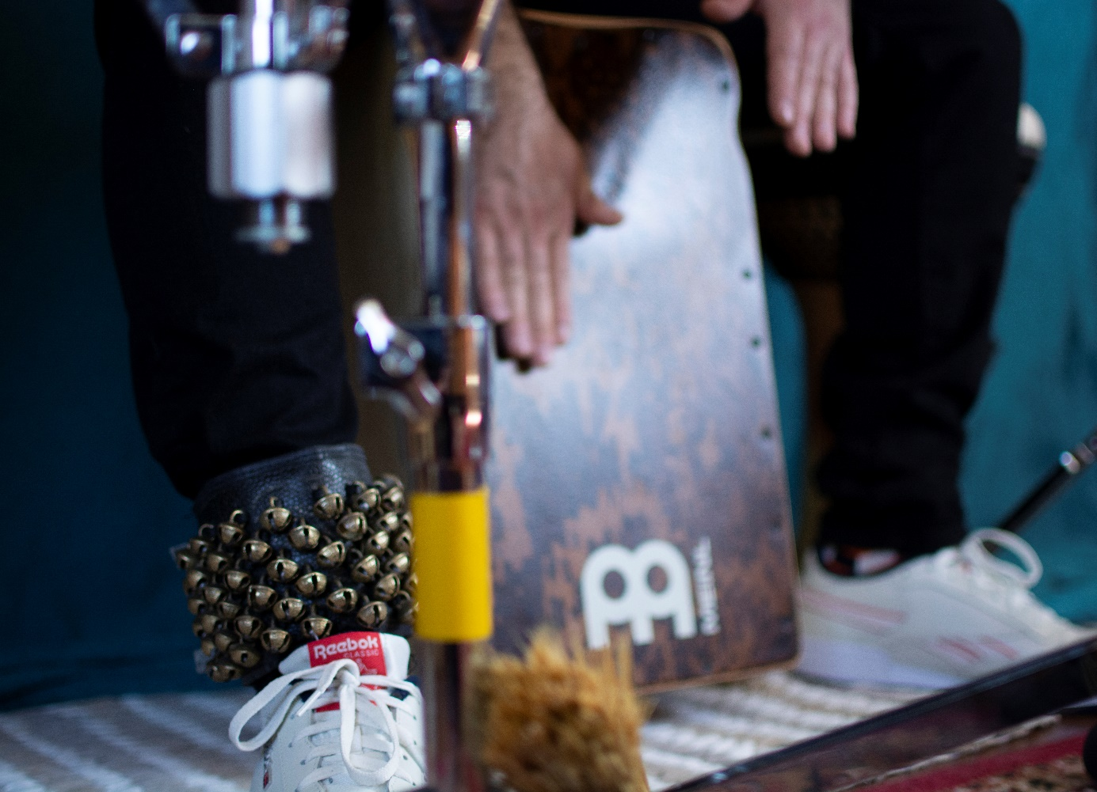

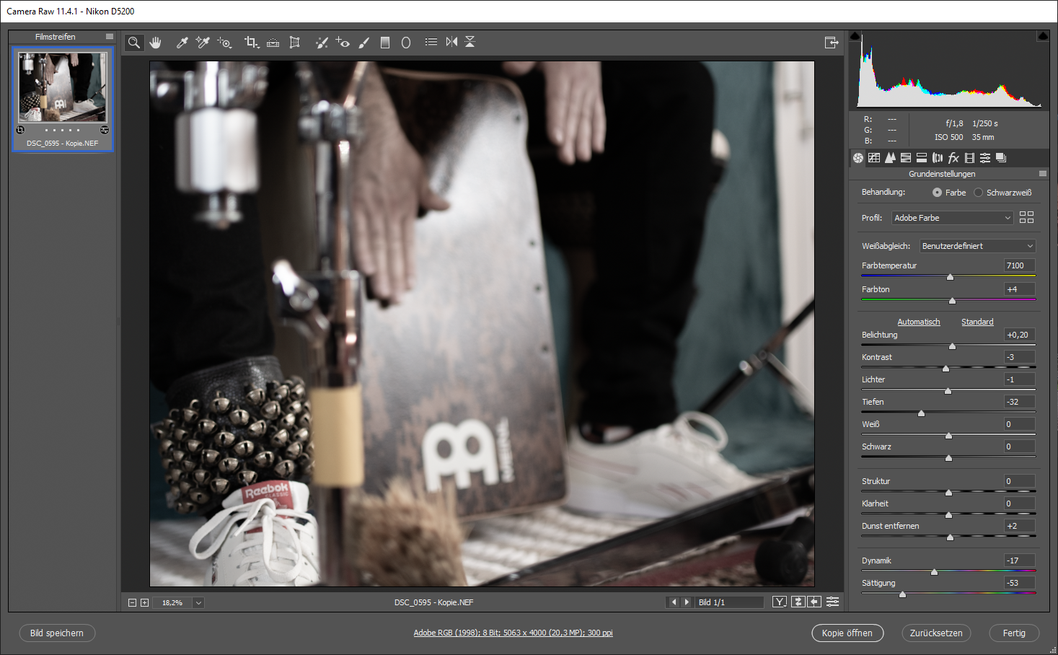

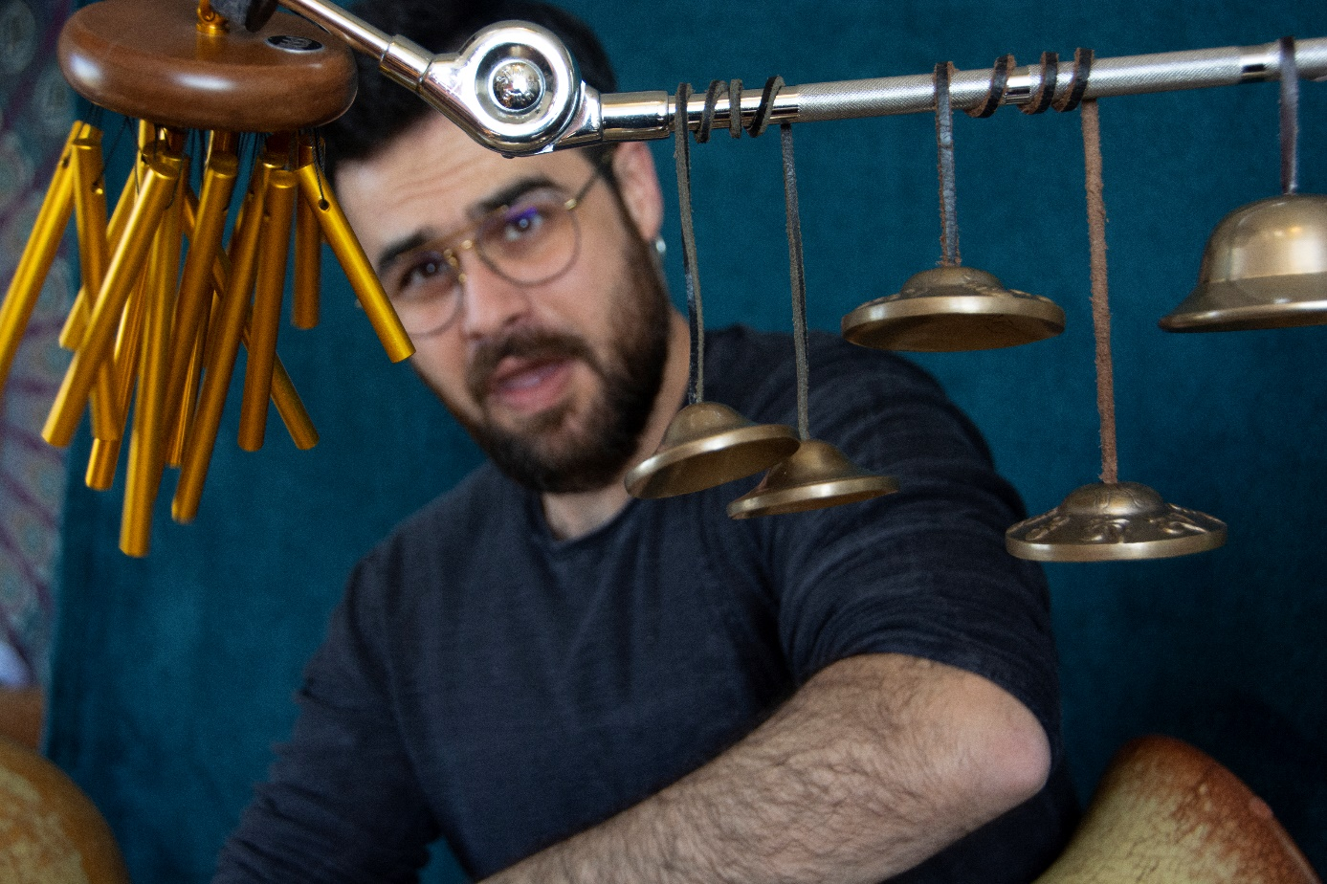

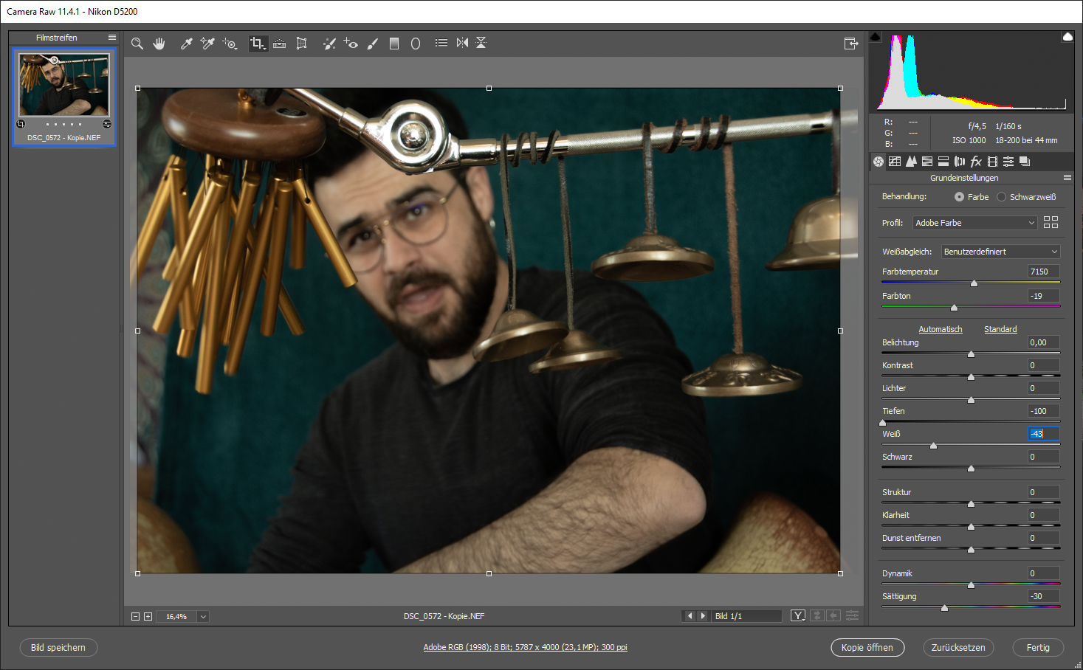

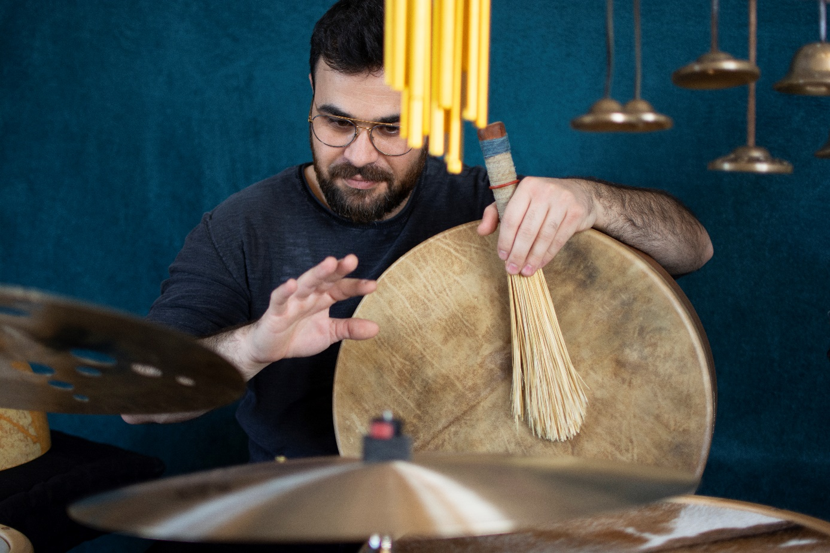

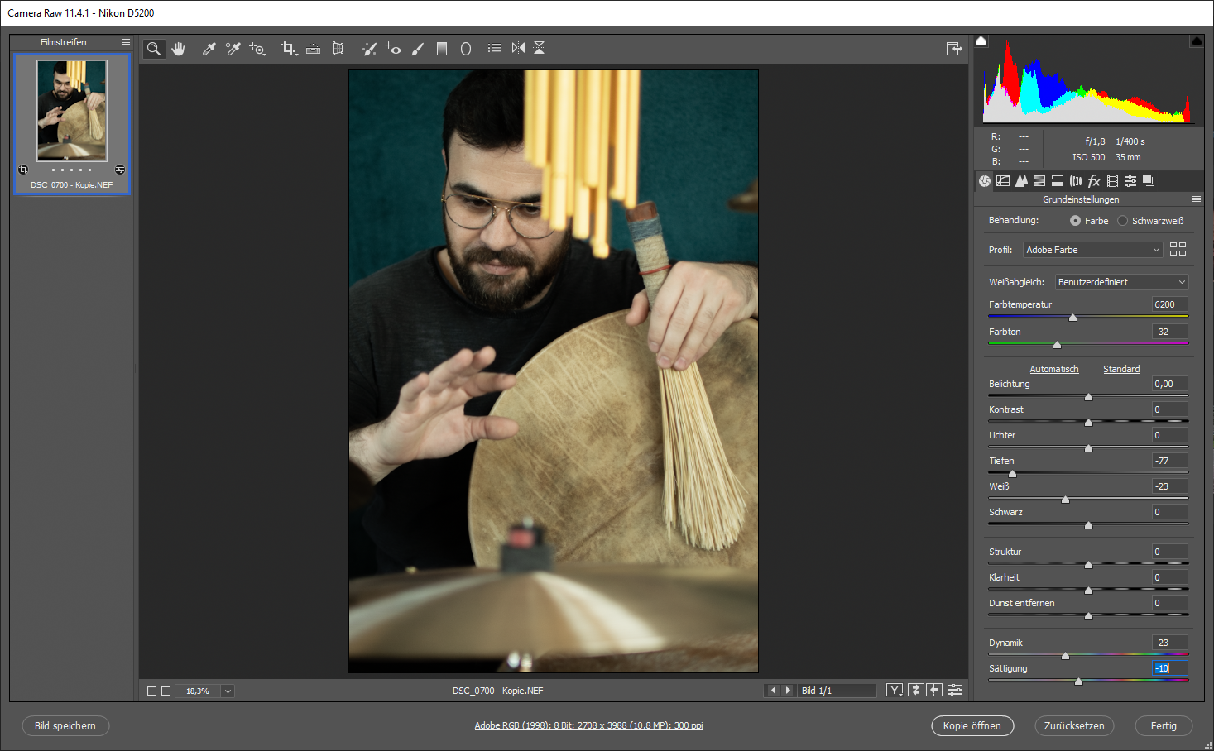

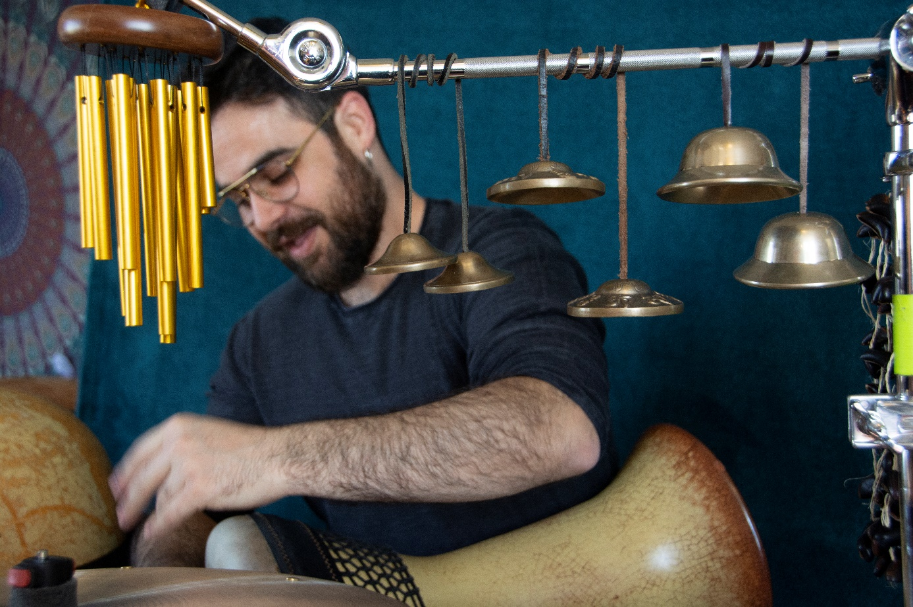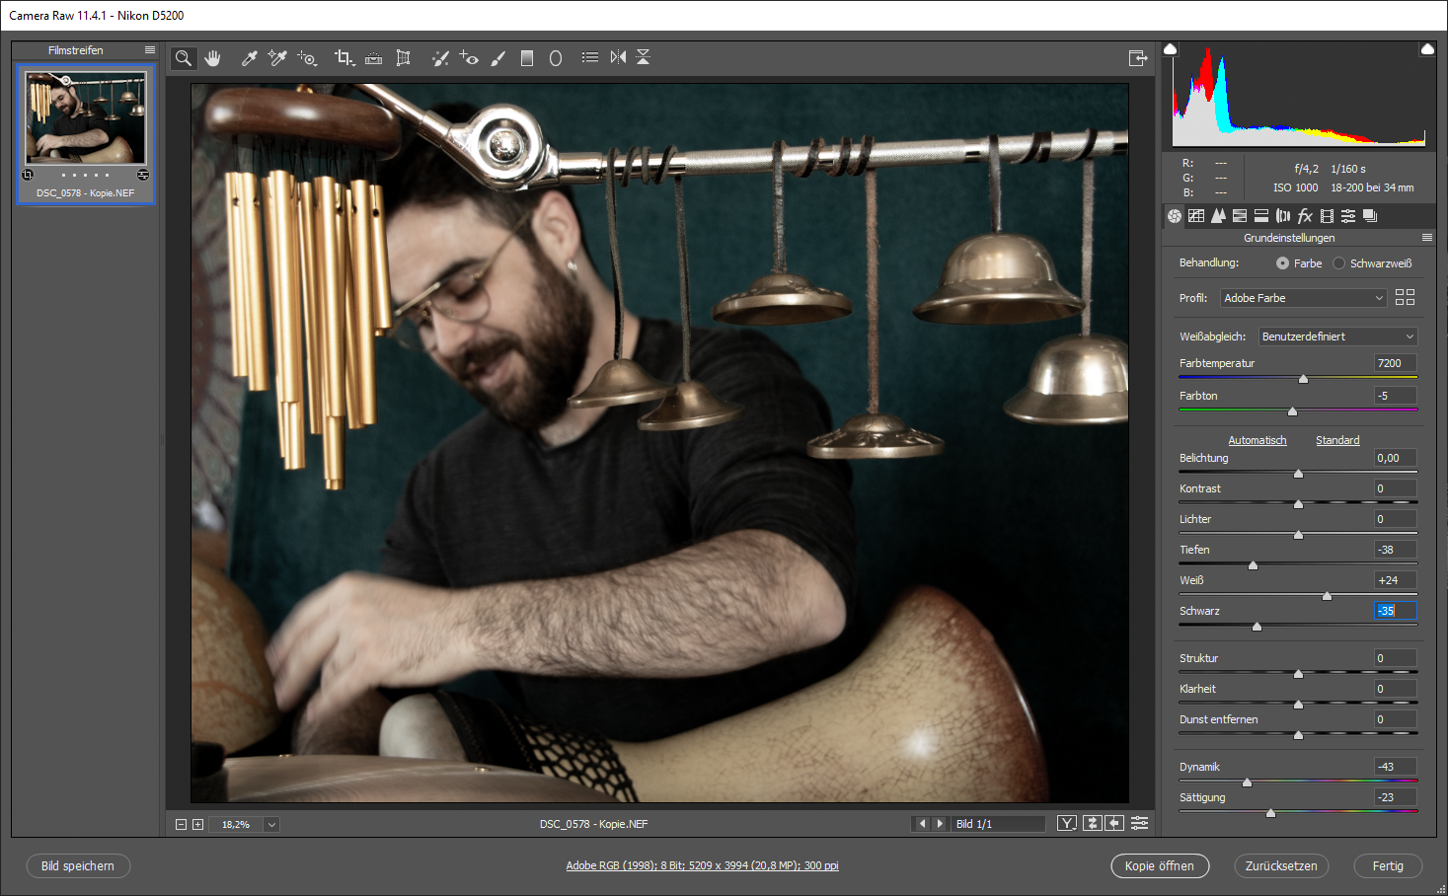

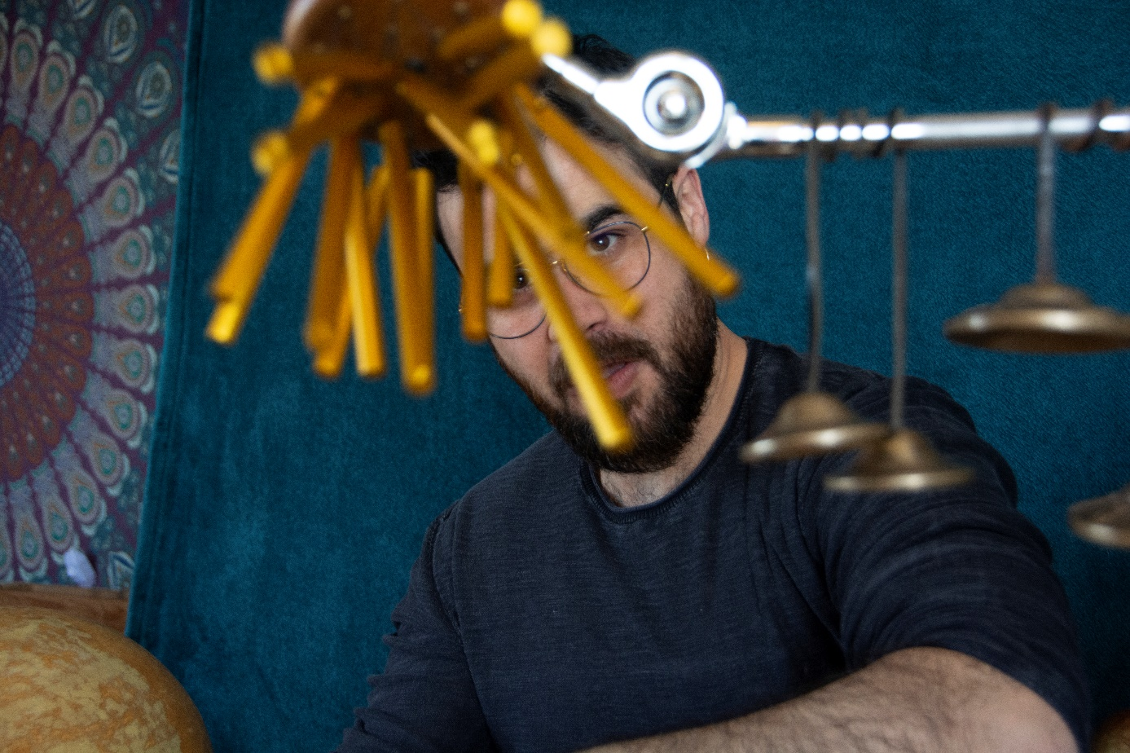

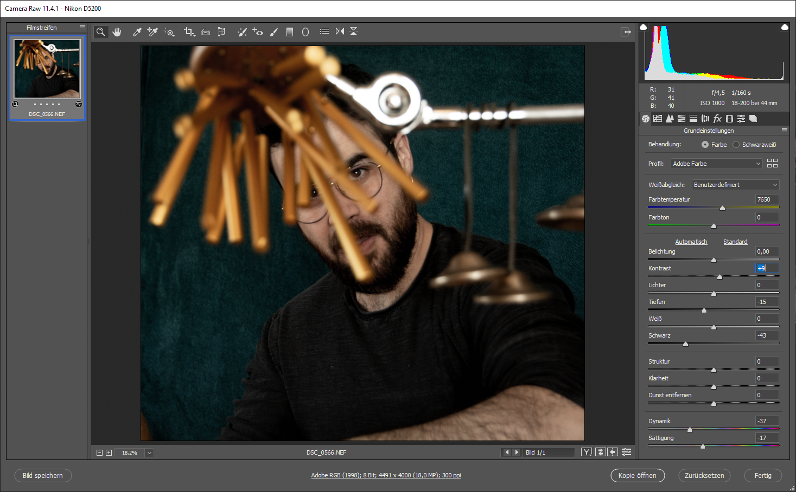

# Portfolio Project Website Dokumentation

Als erste Schritt habe ich die Fotos bearbeitet.

## I. Vorüberlegungen

Ausgehend von den Anforderungen, soll die Website 5 Unterseiten haben:

### Navigation bar:

Die Navigation bar enthält die 5 Seiten (Home – AboutMe – Specialization – Gallery – Contact), außerdem findet der Nutzer in der Navigation die EPK und Privacy (Impressum) als PDF Akte.

### 1. Home /home.html

Die Homeseite besteht aus einem Ausspruch von (John Denver) und einem Hintergrundfoto von mir.

Das Hintergrundfoto verändert sich mit den Tablets und Phones-Größe.

### 2. AboutMe /aboutme.html

Die AboutMe-seite besteht aus 3 Hintergrundfotos und drei Texte.

Text 1. enthält meine Vor und Nachname.

Text 2. enthält einen Überblick über mein Leben.

Text 3. enthält einen Überblick über meine Karriere.

### 3. Specialization /Specialization.html

Auf der Specializationseite soll der Nutzer einen Text über meine Spezialität finden.

Danach folgt drei Videos.

Notiz: habe ich keine Tracks.

### 4. Gallery /Gallery.html

Auf der Galleryseite findet der Nutzer 11 Bilder von mir.

### 5. Contact /contact.html

Hier sollen alle Kontaktinformationen zu finden sein. Email Adresse, Handynummer und die Adresse.

### Footer:

Jede Seite hat ein Footer, wo der Nutzer einen Zugang zu meinen FaceBook und Instagram Kontos hat.

## II. Verwendete Programme

### Editor

Als Editor wurde auf Empfehlung mehrerer Websiten Visual Studio Code gewählt, weil folgende Eigenschaften hat:

1. Kostenlos
2. Leicht zu bedienen / Gut für Anfänger
3. Schnell

## III. Vorgehensweise

### 1. Rohes HTML

Zuerst wurde die Ordnerstruktur nach den Vorüberlegungen entsprechend gewählt und die Dateien erstellt. Dazu wurde noch eine style.css angelegt. Auf index.html wurde mit der Grundstruktur angefangen. Es wurde zuerst nur HTML geschrieben und kein CSS.

Die Mediendateien sollen in den entsprechenden Ordner img abgelegt werden.

Gestartet wurde mit der HTML Struktur on index. Da es sich nur um Struktur handelt.

### home.html

<!DOCTYPE html>

<html lang="en">

<head>

<meta charset="UTF-8">

<meta name="viewport" content="width=device-width, initial-scale=1.0">

<meta http-equiv="X-UA-Compatible" content="ie=edge">

<link rel="stylesheet" href="style.css">

<link href="https://fonts.googleapis.com/css?family=Reem+Kufi&display=swap" rel="stylesheet">

<link rel="stylesheet" href="//use.fontawesome.com/releases/v5.0.7/css/all.css">

<title>Home</title>

</head>

<body>

<main class="main__home">

<div class="background-opicity">

<nav class="navBar">

<nav class="__navBar1">

<a href="home.html" class="home">Home</a>

<a href="about.html" class="about-me">AboutMe</a>

<a href="Specialization.html" class="works">Specialization</a>

<a href="gallery.html" class="contact">Gallery</a>

<a href="contact.html" class="contact">Contact</a>

</nav>

<nav class="__navBar2">

<a href="./img/Workshops-Alaa Salah Eddine..pdf" class="EPK" target="_blanck">EPK</a>

<a href="./img/dsg-dse-030220-16166913.pdf" class="Privacy" target="_blanck">Privacy</a>

</nav>

</nav>

<section class="content">

<div class="text">

<p> “Music does bring people together. It allows us to experience the same emotions. People everywhere are the same in heart and spirit. No matter what language we speak, what color we are, the form of our politics or the expression of our love and our faith, music proves: We are the same.”<br><br>John Denver

</p>

</div>

</section>

<footer>

<ul class="media">

<a href="https://www.facebook.com/alaa.se.9" target="_blanck" class="facebook"><i class="fab fa-facebook-square"></i></a>

<a href="https://www.instagram.com/alaa_salah_eddine/" target="_blanck" class="insteg"><i class="fab fa-instagram"></i></a>

</ul>

</footer>

</div>

</main>

</body>

</html>

### aboutme.html

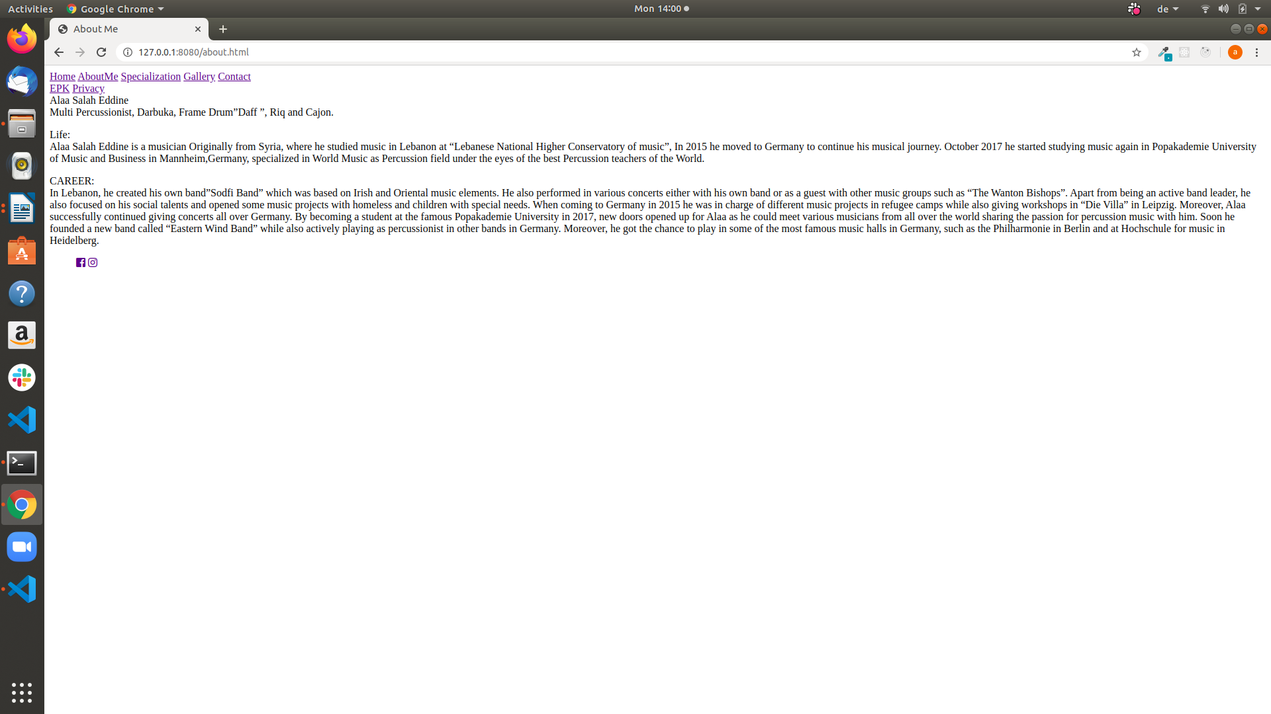<body>

<main class="main__about-me">

<section class="foto-container">

<div class="pic1">

<div class="tex1">

<span class="name">Alaa Salah Eddine</span><br>

<span class="__name">Multi Percussionist, Darbuka, Frame Drum”Daff ”, Riq and Cajon.</span>

</div>

</div>

<div class="pic2">

<p class="tex2"><span class="life">Life:</span><br>

Alaa Salah Eddine is a musician Originally from Syria, where he studied music in Lebanon at

“Lebanese National Higher Conservatory of music”, In 2015 he moved to Germany to

continue his musical journey. October 2017 he started studying music again in Popakademie

University of Music and Business in Mannheim,Germany, specialized in World Music as

Percussion field under the eyes of the best Percussion teachers of the World.</p>

</div>

<div class="pic3">

<p class="tex3"><span class="career">CAREER:</span><br>

In Lebanon, he created his own band”Sodfi

Band” which was based on Irish and Oriental

music elements. He also performed in various

concerts either with his own band or as a

guest with other music groups such as “The

Wanton Bishops”. Apart from being an active

band leader, he also focused on his social

talents and opened some music projects with

homeless and children with special needs.

When coming to Germany in 2015 he was in

charge of different music projects in refugee

camps while also giving workshops in “Die

Villa” in Leipzig. Moreover, Alaa successfully

continued giving concerts all over Germany.

By becoming a student at the famous Popakademie University in 2017, new doors opened up for Alaa as he could

meet various musicians from all over the world sharing the passion for percussion music with him. Soon he founded a

new band called “Eastern Wind Band” while also actively playing as

percussionist in other bands in Germany.

Moreover, he got the chance to play in some of the most famous music halls in Germany, such as the Philharmonie in

Berlin and at Hochschule for music in Heidelberg.</p>

</div>

</section>

</main>

</body>

### Specialization.html

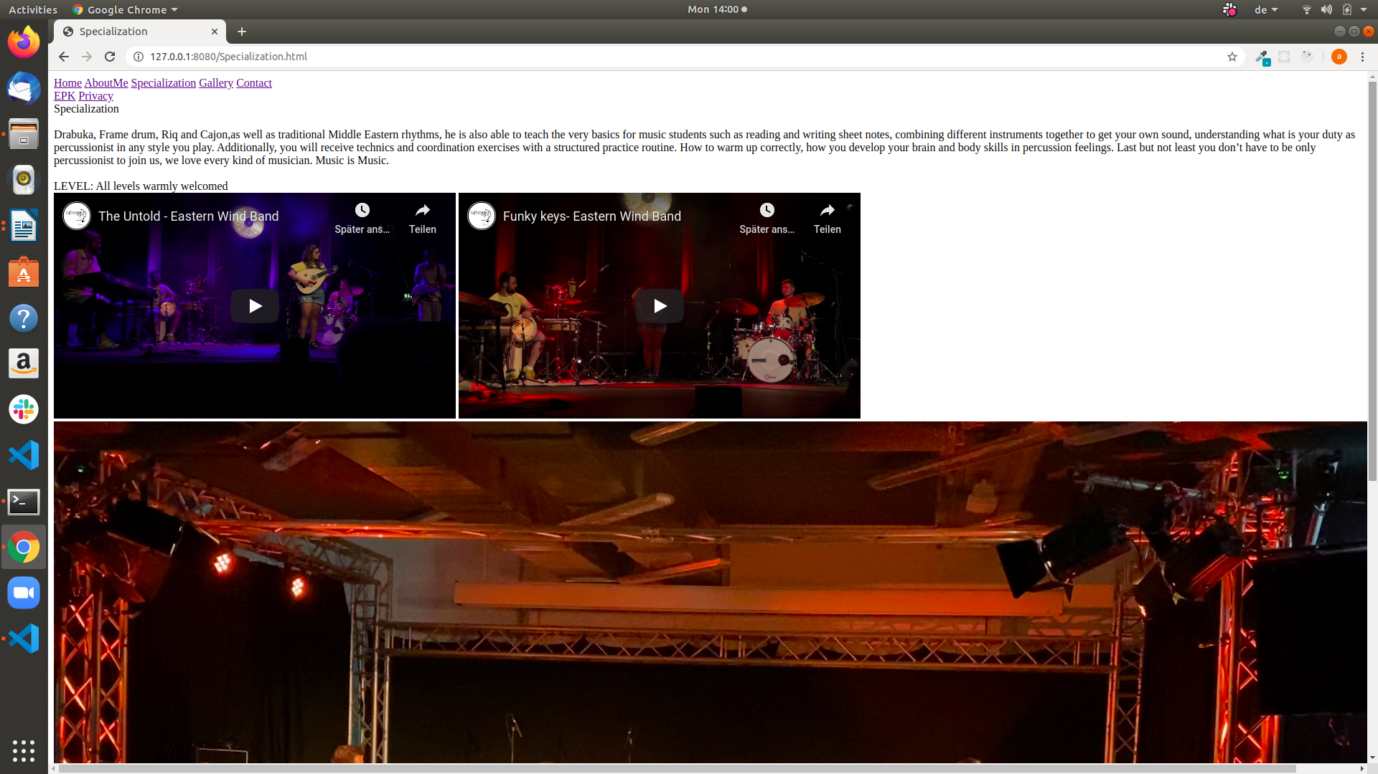<body>

<main class="main__specialization">

<section class="back-specialization">

<div class="text-specialization">

<div class="__text-specialization"><span class="speci"> Specialization</span><br><br> Drabuka, Frame drum, Riq and Cajon,as well as traditional Middle Eastern rhythms, he is also

able to teach the very basics for music students such as reading and writing sheet notes, combining different

instruments together to get your own sound, understanding what is your duty as percussionist in any style

you play. Additionally, you will receive technics and coordination exercises with a structured practice routine.

How to warm up correctly, how you develop your brain and body skills in percussion feelings. Last but not

least you don’t have to be only percussionist to join us, we love every kind of musician. Music is Music.<br><br>

<span>LEVEL: All levels warmly welcomed</span>

</div>

</div>

</section>

<section class="videos">

<iframe width="560" height="315" src="https://www.youtube.com/embed/JGPWfqUxHE8" frameborder="0" allow="accelerometer; autoplay; encrypted-media; gyroscope; picture-in-picture" allowfullscreen></iframe>

<iframe width="560" height="315" src="https://www.youtube.com/embed/hBngKLjX1ys" frameborder="0" allow="accelerometer; autoplay; encrypted-media; gyroscope; picture-in-picture" allowfullscreen></iframe>

</section>

<section class="video2">

<video src="./img/Mike-Herting.mp4" src="Mike-Herting.mp4" controls>

</video>

</section>

</main>

</body>

### Gallery.html

### 

<body>

<main class="main__gallery">

<section class="gallery-container">

<div class="cover"><img src="./img/DSC_0372.jpg" alt="Alaa" class="img"></div>

<div class="cover"><img src="./img/DSC_0406.jpg" alt="Alaa" class="img"></div>

<div class="cover"><img src="./img/DSC_0416_2.jpg" alt="Alaa" class="img"></div>

<div class="cover"><img src="./img/DSC_0442_1.jpg" alt="Alaa" class="img"></div>

<div class="cover"><img src="./img/DSC_0566_2.jpg" alt="Alaa" class="img"></div>

<div class="cover"><img src="./img/DSC_0595 - Kopie.jpg" alt="Alaa" class="img"></div>

<div class="cover"><img src="./img/DSC_0691 - Kopie.jpg" alt="Alaa" class="img"></div>

<div class="cover"><img src="./img/IMG_62080.jpg" alt="Alaa" class="img"></div>

<div class="cover"><img src="./img/DSC_0578 - Kopie_1.jpg" alt="Alaa" class="img"></div>

<div class="cover"><img src="./img/DSC_0700.jpg" alt="Alaa" class="img"></div>

<div class="cover"><img src="./img/DSC_0638 - Kopie_1.jpg" alt="Alaa" class="img"></div>

</section>

</main>

</body>

### contact.html

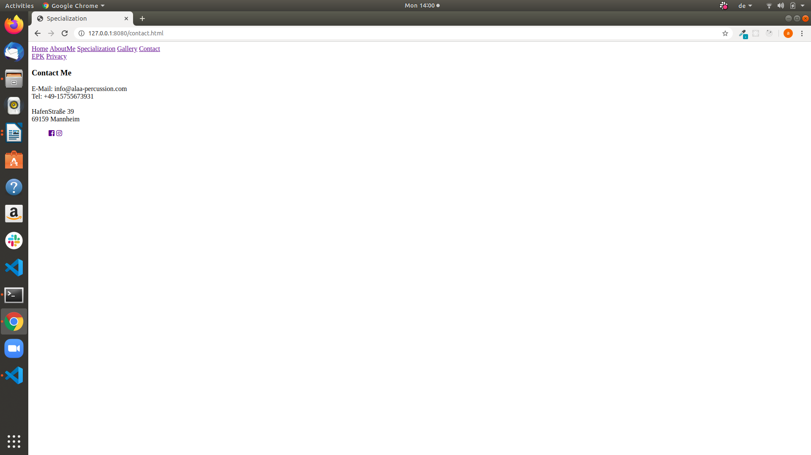<body>

<main class="main__contact">

<section class="back-contact">

<div class="text-contact">

<h3 class="contact-me">Contact Me</h3>

<div class="email-tel">

E-Mail: info@alaa-percussion.com<br>

Tel: +49-15755673931<br><br>

HafenStraße 39<br>

69159 Mannheim

</div>

</div>

</section>

</main>

</body>

### 2. Styling/CSS

In der styles.css wird Google Fonts und font awesome (für die icons) verwendet.

Es wurde die Schriftart „Reem Kufi“ gewählt.

## IV. Verwendete Tools

* Visual Studio Code
* Google Fonts
* font awesome
* Github